Task to be submitted alongside your entry form
Deadline – 30th April 2018
Create an online video advert promoting your college restaurant to local businesses and the local community

You have been tasked to create an online video advert designed to promote your college restaurant that you can use on your website and on social media
The video must be a maximum of 90 seconds in length and is designed to showcase the restaurant and kitchen teams.
You may wish to include:-
- Interviews with learners
- Interviews from customers / local businesses
It should focus on your why people come, why people should try your restaurant and what makes you different
It should clearly promote the college and where you are located as well as contact details and opening times
An information sheet (Creating a great video) is attached and contains full details on how to submit the advert to the judges.

Guidelines – creating a great video
We have put together these simple guidelines to help you record good-quality videos to for the AA award challenge to promote your college restaurant.
Before filming
- Find a private area for filming where you won’t be interrupted. A quiet, indoor location where people won’t be passing through is best - the sound of the wind or passing traffic can easily interfere with sound quality when filming outside, while background conversations, doors banging, phones ringing and footsteps call all cause sound problems indoors.
- Make sure that the environment is well-lit. Your subject should be lit from the front (the light source should come from behind the camera) and you should make sure there are no bright lights or windows in the background
- Design your ‘set’ to make it look as professional as possible and avoid distracting backgrounds
Setting up your video
- The video should be taken in landscape and NOT portrait orientation (If you’re using your phone, don’t hold the phone upright, but turn it on its side to film)
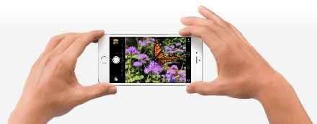

- We highly recommend filming in HD (most mid-range cameras and phones have this setting available)
- Your video should be taken in colour, not black and white
- The focus of the lens should be on the subject
- We recommend using either of the following settings for your video: 720p HD at 30 frames/per second (which will make the file size 60MB per minute) or 1080p HD at 30fps (default resolution), which will make the file 130MB per minute
- If possible, use a mic and a tripod – if you don’t have a tripod, ask someone to hold the camera steady with two hands to reduce shaking whilst recording
- Once you’ve set your camera up and begun filming, avoid moving it if possible – it can be distracting to the viewer if the background keeps switching backwards and forwards during a video!

After filming
- When you’ve completed your video, save it and send it to accreditation@people1st.co.uk. The file is likely to be too large to email, so we recommend using WeTransfer (www.wetransfer.com) to transfer the file. This is a free service which can be used to transfer files up to 2GB in size, and you don’t need to register or sign up to use it.
- Please advise accreditation@people1st.co.uk as soon as you have decided to submit a nomination so we can ensure we don’t miss your submission.

